EANGUS AREA V Caucus
15-17 MAY 2020
@

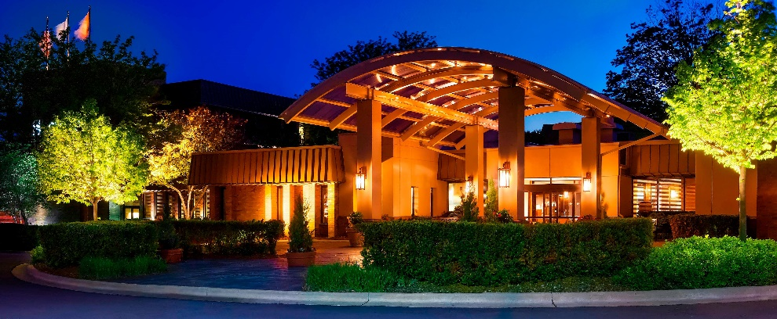
Sheraton Milwaukee Brookfield Hotel.

375 S. Moorland Road

Brookfield, WI 53005

Rooms: Room rate will be $103.00 plus tax per night. All rooms are available at the listed rate for 15-16 May 2020 plus 3 nights before and after the event. Room types are a traditional DBL and a traditional King. Rooms must be scheduled no later than 20 April 2020 to guarantee this rate. Call 1-800-325-3535 or 262-364-1100 to book your room under the EANGUS Area V Caucus.

Registration: $35.00 per person, includes lunch on Saturday and Friday and Saturday night Hospitality Room activities. Send Registration form to WNGEA, Attn: Gary Hans, 2400 Wright Street, Box 39, Madison, WI 53704 or email to wngea@yahoo.com.

Schedule: Friday night Hospitality Ice Breaker will start at 1600. Hospitality room will

be available on Saturday night also. Saturday Caucus Agenda will be published by Chuck Kasin at a later date.

Registration

Name: ______________________________________________

State Association:____________________________________

Address:____________________________________________

Email:_______________________________________________

Cell Phone:__________________________________________
Please send above information for each person attending the event. Checks can be written for full amount of your party. Send all information to Gary Hans at WNGEA, 2400 Wright Street, Box 39, Madison, WI 53704. I can also be reached at 920-723-8098 or email wngea@yahoo.com if you have any questions. Thank you.

