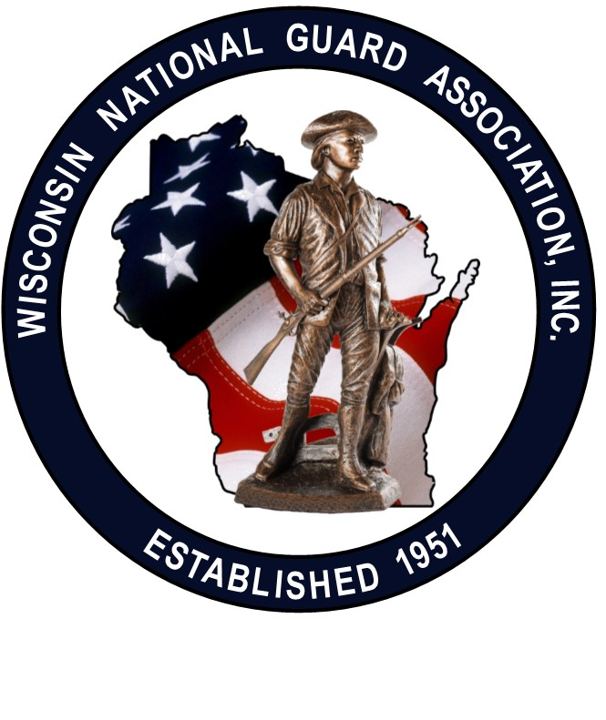
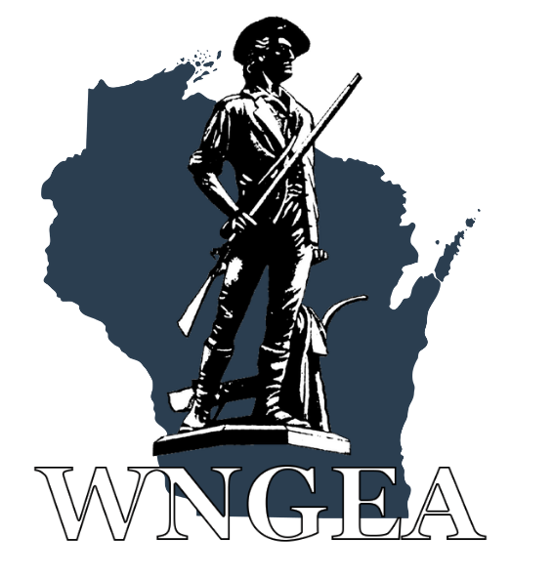

The Wisconsin National Guard wants to thank you for registering to attend the 2023 WINGA/WNGEA State Conference in WI Dells. Special thanks to our host unit, Joint Force Headquarters (JFHQ). This Letter of Instruction (LOI) will provide you with additional details to make your experience satisfying and rewarding.

- Registration: when you arrive at the Chula Vista Resort and Waterpark in WI Dells, 2501 River Road, stop by the conference registration table. Follow the signs past the hotel registration desk. The hotel has free parking and wi-fi. Please wear your name badge at all times as this is your ticket to get access to all conference events and our hospitality room.
- Hotel: room rate is $104/night + tax for double or king beds. Your fee includes complimentary waterpark passes for all adults and children. If you haven’t already done so, you can reserve a room at the Chula Vista by calling 844.974.0678, code#I243696.
- Family Activities: there are many tourist activities in the WI Dells area for your enjoyment. Other than a complimentary breakfast and optional golf on Sunday, you have the opportunity to enjoy the Chula Vista Waterpark or explore other family activities in the WI Dells area.
- Evaluation Form: Conference evaluation forms will be available at the registration table or on the conference app. Your feedback is very important and will help us improve the 2024 State Conference.
- Dress Code: military dress is not required this year. If you are receiving an award, you have the option of wearing your Class A uniform or a civilian equivalent. Senior military leaders and retirees are welcome to wear their uniform at any time. Conference dress code is business casual for PD sessions and the Saturday banquet. Dress code in the hospitality room is casual.
- Conference App: Go to the App store and enter WNGEA (Wisconsin National Guard Enlisted Association). Once the app is downloaded, click on “Events” at the bottom of the page. Then click on “WINGA/WNGEA/RAVA Conference Information.”
- Ice Breaker Social: this event is our meet and greet social combined with our corporate partner trade show. We have 20 vendor tables this year. This event is 6:00-9:00 pm on Friday in the Lower Atrium (see attached hotel floor plan). This event has a sports theme, so you are welcome to wear attire of your favorite team. Food and beverages are provided including complimentary beer (5 varieties), wine (3 varieties) and soft drinks. There is also a cash bar available. Do not consume alcohol if you are not of legal age. There will be several floor games available for your enjoyment.
- Vendor Bingo: During the Ice Breaker, we have an optional vendor bingo game. Get all of the bingo logos stamped by the vendors and turn your card in for great prizes. If you decide to not play bingo, please take the time to thank our corporate partners. There will also be a meat raffle.
- Hospitality Room: the conference hospitality room is located in the Sierra Vista Room which is on the second level above the hotel lobby. Complimentary beverages and snacks are available. Please wear your name badge. This room is open 9:00 pm-12:00 am Friday. Saturday hours are 4:15-5:30 pm and 9:00 pm-12:00 am.
- Meals: all meals are complimentary and included in your registration, with the exception of the banquet which was an optional additional charge of $30/person. Check the confernce app for times and locations.
- Opening Ceremony: this event takes place in the Lower Atrium from 8:00-9:20 am. Dress is business casual. If you are an award recipient, to can wear your Class A uniform or civilian equivalent. This is our opening program to include awards and several speakers including, Maj Gen Paul Knapp, The Adjutant General.
- Award Recipients: individual awards will be presented during the Opening Ceremony. When your name is called, please come forward to receive your award from senior military leaders. A photo session will take place at the conclusion of the ceremony. Reminder to wear your Class A uniform or civilian equivalent.
- Professional Development (PD) Sessions: there are several PD sessions during the conference on Friday & Saturday. Military leaders and professional speakers will offer a variety of topics to enhance your military and civilian careers. Spouses are welcome to attend all conference events. Those of you in a paid status should attend all PD Sessions.
- WINGA/WNGEA Annual Business Meetings: these two PD sessions are conducted concurrently on Saturday morning from 11:00 am to 12:20 pm. All officers and enlisted are expected to attend their respective association meetings.
- Golf Outing: there is an optional 9-hole outing at Cold Water Canyon Golf Club which is on the Chula Vista property. More information will be on the conference app.
Your Wisconsin National Guard State Conference is hosted by JFHQ and sponsored by the Wisconsin National Guard Association, Inc (WINGA) and the Wisconsin National Guard Enlisted Association, Inc. (WNGEA). This year, we are also joined by the Red Arrow Veterans Association (RAVA). All three Associations are membership-based organizations which provide programs and services to benefit Wisconsin National Guard Soldiers, Airmen and their families. Please consider membership in one or more of these organizations so they can enhance future benefits for the National Guard community.

Safe travels to Wisconsin Dells.
Your 2023 Conference Planning Team

