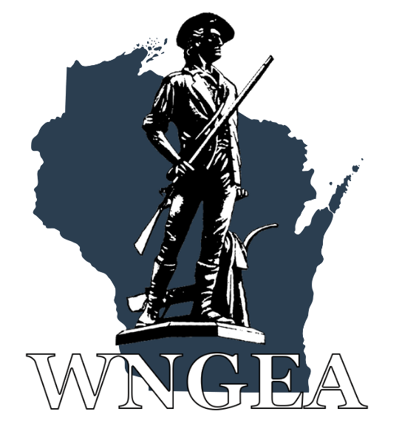

The Wisconsin National Guard wants to thank you for registering to attend the 2024 WINGA/WNGEA State Conference at the Osthoff Resort in Elkhart Lake, WI. Special thanks to our host units, the Recruiting and Retention Battalion and the 426th Regimental Training Institute. This Letter of Instruction (LOI) will provide you with additional details to make your experience satisfying and rewarding.

- Registration: when you arrive at the Osthoff Resort in Elkhart Lake, WI, 101 Osthoff Avenue, stop by the conference registration table. Follow the signs past the hotel registration desk to the Grand Libelle Foyer to register. The hotel has free parking and wi-fi. Please wear your name badge at all times as this is your ticket to get access to all conference events and our hospitality room.
- Hotel: room rate is $90.00/night for a single and $129.00 for a double + tax. If you haven’t already done so, you can reserve a room at the Osthoff Resort by calling 1.800.876.3399. Room block is under the Wisconsin National Guard.
- Family Activities: there are many tourist activities in the Elkhart Lake area for your enjoyment. On Saturday the Osthoff Resort will be offering a Cooking School and a Yoga Demonstration and a Spouse Listening Session. Childcare is available on Friday and Saturday evenings.
- Evaluation Form: Conference evaluation forms will be available at the registration table or on the conference app. Your feedback is very important and will help us improve the State Conferences of the future.
- Dress Code:
Ice Breaker Social and Hospitality Rooms: Casual Civilian
Award Ceremony, Business meetings, Professional Development: Business Casual Saturday Social, Banquet meal: Semi-formal, Business Attire, or Military Uniform (ASU/Class A/Mess Dress)
- Conference App: Go to the App store and enter WNGEA (Wisconsin National Guard Enlisted Association). Once the app is downloaded, click on “Combined Conference” at the top of the page.
- Ice Breaker Social: this event is our meet and greet social combined with our corporate partner trade show. We have 20 vendor tables this year. This event is 6:00-9:00 pm on Friday in the Grand Libelle Ballroom, (see hotel floor plan). This event has a sports theme, so you are welcome to wear attire of your favorite team. Food and beverages are provided including complimentary beer (5 varieties), wine (3 varieties) and soft drinks. There is also a cash bar available. Do not consume alcohol if you are not of legal age. There will be mini golf, Bingo prizes, 50:50 raffle, and more.

- Vendor Bingo: During the Ice Breaker, we have an optional vendor bingo game. Get all of the bingo logos stamped by the vendors and turn your card in for great prizes. If you decide to not play bingo, please take the time to thank our corporate partners.
- Joint Hospitality Rooms:
Friday Evening (9:00 pm to 12:00 am): the Hospitality room is located in the Elkhart Lake Ballroom and the Lake View Room which is on the lower level below the Hotel lobby. Guitar music will be provided. Complimentary beverages and snacks are available both evenings.
Saturday Evening (9:00 pm to 12:00 am): the Hospitality room will be in the Grand Libelle DEF. Dueling Piano’s will be the entertainment.
Please wear your name badge both evenings.
- Meals: all meals are complimentary and included in your registration, with the exception of the banquet which was an optional additional charge of $30/person. Check the conference schedule or the conference app for times and locations.
- Opening Ceremony: this event takes place in the Palm Gardens ABC from 8:00-9:00 am on Saturday. Dress is business casual. This is our opening program and includes the WNGEA Award Presentations for the National Guard Army and Airmen of the year.
Maj Gen Paul Knapp, The Adjutant General will provide opening remarks.
- Award Recipients: individual awards will be presented during the Opening Ceremony. When your name is called, please come forward to receive your award from senior military leaders. A photo session will take place at the conclusion of the ceremony.
- Professional Development (PD) Sessions: there are several PD sessions on Saturday, see the Conference agenda. Military leaders and professional speakers will offer a variety of topics to enhance your military and civilian careers. Spouses are welcome to attend all conference events. Those of you in a paid status should attend all PD Sessions.
- WINGA/WNGEA Annual Business Meetings: these two PD sessions are conducted concurrently on Saturday morning from 10:30 am to 12:00 pm. All officers and enlisted are expected to attend their respective association meetings.
- Golf Outing: there is an optional 9-hole outing at Quit Qui Oc Golf Club which is in Elkhart Lake. More information will be on the conference schedule and on the app.
- Your Wisconsin National Guard State Conference is hosted by the Recruiting and
Retention Battalion and the 426th RTI and sponsored by the Wisconsin National Guard
Association, Inc (WINGA) and the Wisconsin National Guard Enlisted Association, Inc.
(WNGEA). These Associations are membership-based organizations which provide
programs and services to benefit Wisconsin National Guard Soldiers, Airmen and their
families. Please consider membership in one or more of these organizations so they can
enhance future benefits for the National Guard community.

Your 2024 Conference Planning Team

