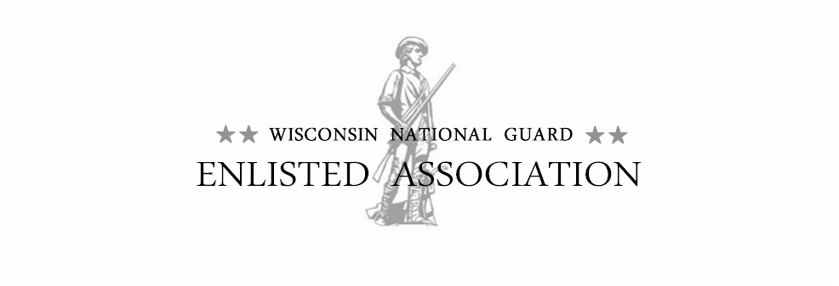
To All Executive Council Members 29 Oct 2024

This is to notify you that there will be a quarterly WNGEA Executive Council meeting.

Date: 18 January 2025 (Saturday) Place date on your calendar!
Time: 0930-1230 hours
Place: JFHQ’s, 2400 Wright Street, Room 160, Madison, WI
Report Period: January to December 2024
Committee Reports due by: COB: Monday/13 January 2025

The January Executive Council meeting will be held at the Joint Force Headquarters in Madison, WI. Coffee/Tea will be available during the meeting.

Conference Call option will be available as follows: Local: 608.242.3802 or 608-242.3805.
Toll free: 1.877.533.6691, entry code: 23114#

If you have a quarterly report for this meeting it should reflect the business and issues for 2024. If you are unable to attend the meeting, please notify me via email, phone call, or text (920-723-8098). If you have input for Old or New Business, please include your comments when you send your report.

On Tuesday (14 January), after the report due date, reports will be printed and assembled in the reports packet for the meeting. Upon receipt, I will send a confirmations that I received your report. If you do not receive a confirmation, contact me for clarification. For anyone that cannot or did not meet this deadline, please bring your reports to the meeting. New information, or a negative report can be presented orally to save paper, and it will be recorded into the minutes.

Please forward this notification to anyone you know who may be interested in knowing more about the association.

Sincerely:

//signed//
Gary R. Hans, Sergeant Major, Retired
WNGEA Executive Director
920-723-8098

