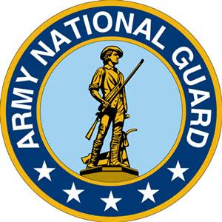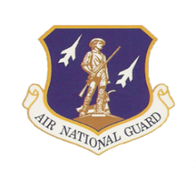 **Company Grade Officer and Enlisted**

**Professional Development Training**

The 115th Fighter Wing is hosting the 2025 Wisconsin National Guard State Conference at the DoubleTree Hotel, 4402 E. Washington Avenue, Madison, WI, on 25-27 April. This event is co-sponsored by the Wisconsin National Guard Association (WINGA) and the Wisconsin National Guard Enlisted Association (WNGEA).

In addition to our Wisconsin National Guard Interim Adjutant General, several professional speakers have been invited to the conference to share their expertise on topics to improve and enhance leadership, teamwork, legislative awareness, and mentorship skills. The following is a summary of our professional development speakers and their qualifications.



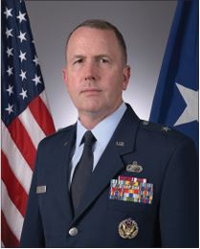Brig. Gen. David W. May is Wisconsin’s deputy adjutant general for Air. He is currently serving as the Interim Adjutant General. He serves as the chief advisor on all matters pertaining to Air National Guard programs, policies, operations, management and command and control of the Wisconsin Air National Guard. He also provides staff assistance guidance and direction concerning Air National Guard personnel, administration, training, recruiting and retention incentives, and budgetary matters. Gen. May is responsible for more than 2,300 Wisconsin Air National Guard personnel serving in two flying wings and a Combat Readiness Training Center at Volk Field Air National Guard Base. Brig. Gen. May earned a bachelor’s degree in music at Kent State University in 1993. He earned a master’s degree in music at the University of Michigan in 1994, and a doctorate in philosophy, organization and management at Capella University in Minneapolis, Minnesota in 2003. He completed Squadron Officer School, Air Command and Staff College at Maxwell-Gunter Air Force Base by correspondence, Command and General Staff College at Fort Leavenworth, and Air War College at Maxwell-Gunter Air Force base by correspondence. Brig. Gen. May received his commission through the Air Force Officer Training School, Maxwell Air Force Base, Alabama, in August 1996. He has held a variety of command and staff positions at the wing, combatant command, Air Staff, and Joint Force Headquarters level. His staff tours include HQ U.S. Air Force, the Pentagon, HQ Air Force Cyber Command (Provisional), U.S. Transportation Command, and the Joint Force Headquarters of the Wisconsin National Guard. He assumed his current rank and duties April 16, 2020. Prior to his current assignment, he commanded Volk Field Air National Guard Base, Camp Douglas, Wisconsin, which includes the Combat Readiness Training Center, the 128th Air Control Squadron, and the 126th Weather Flight. Brig. Gen. May’s major military awards include the Legion of Merit, the Meritorious Service Medal with three oak leaf clusters, the Joint Service Commendation Medal, the Air Force Commendation Medal with three oak leaf clusters, the Joint Service Achievement Medal, the Air Force Commendation Medal with three oak leaf clusters, the Joint Meritorious Unit Award with one oak leaf cluster, the Air Force Outstanding Unit Award with three oak leaf cluster, the Air Force Organizational Excellence Award with one oak leaf cluster, the National Defense Service Medal, the Global War on Terrorism Service Medal, the Air Force Overseas Ribbon Long, and the Air Force Expeditionary Service Ribbon with gold birder and one oak leaf cluster.

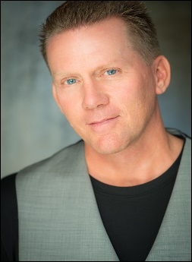Over 25 years ago, Dave Davlin began bringing smiles to faces with a form of entertainment he developed as a young boy. From NBA and major college arenas across America to the Summer Olympic Games in Seoul, South Korea— and even to the world-famous Branson Strip— “Travelin” Davlin has entertained people of every age and background. His amazing ability with basketballs even landed his name and picture in the 1990 Guinness Book of World Records. Dave began to hone his speaking skills in the early 90’s as a national speaker in the public schools across America. Combining his entertainment ability with a powerful message, he was instrumental in the fight for education and against drugs. At the advice of friends working in corporate America, Dave began to develop presentations for the corporate and association market and the rest is history. He now speaks at numerous corporate and associational conferences each year. From public school students to CEOs, Dave’s message has made a difference in the lives of thousands, and his impact continues to grow each year as he shares his philosophy and wisdom through speaking and writing.