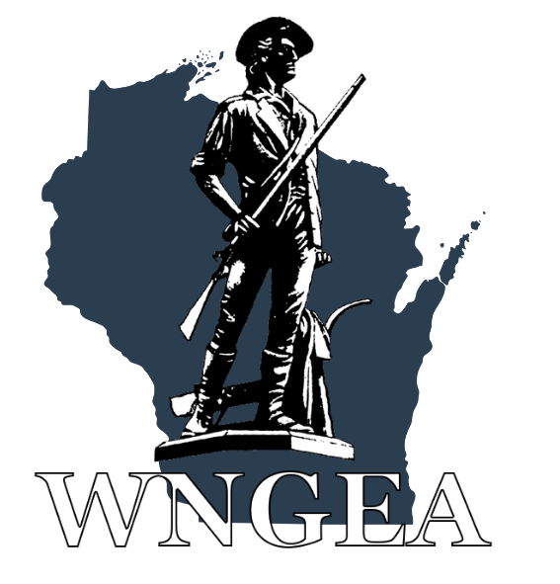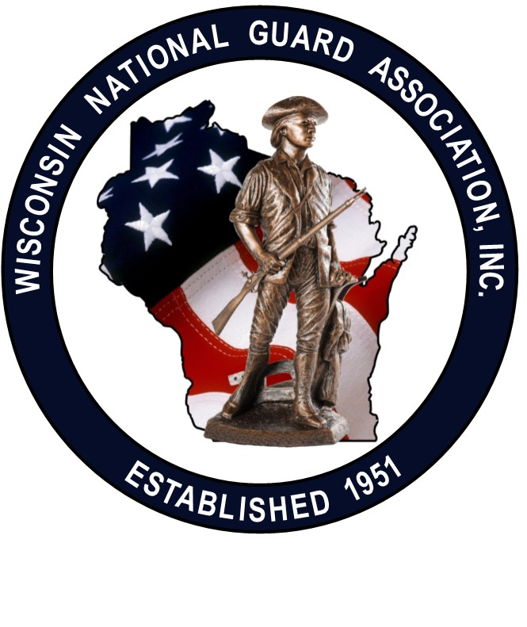

The Wisconsin National Guard Officer/Enlisted Associations wants to thank you for registering to attend the 2025 WINGA/WNGEA State Conference at the Double Tree Madison East in Madison, WI. Special thanks to our host units, the 115th Fighter Wing and the Volk Field ANG Base. This Letter of Instruction (LOI) will provide you with additional details to make your experience satisfying and rewarding.

1. **Registration**: when you arrive at the Double Tree Madison East, 4402 E. Washington Avenue, Madison, WI, stop by the conference registration table on your left from the main entrance. The hotel has free parking and Wi-Fi. Please wear your name badge at all times as this is your ticket to get access to all conference events and our hospitality room.
2. **Hotel**: room rate is $98.00/per night plus tax. If you haven’t already done so, you can reserve a room at the Double Tree Madison East by calling 608-244-4703. Room block name is “WIN” under the Wisconsin National Guard or use this link: Reservation Deadline is 11 April 2025. [Available Rooms - DoubleTree by Hilton Madison East](https://www.hilton.com/en/book/reservation/rooms/?ctyhocn=MSNMADT&arrivalDate=2025-04-25&departureDate=2025-04-27&groupCode=CDTWIN&room1NumAdults=1&cid=OM%2CWW%2CHILTONLINK%2CEN%2CDirectLink)
3. **Family Activities**: there are many tourist activities in the Madison area for your enjoyment. On Saturday at the Double Tree Madison East we will be offering a “Paint and Sip” class and a Spouse Listening Session. Childcare is available on Friday and Saturday evenings. Sign up for child care is on the registration form.
4. **Evaluation Form:** Conference evaluation forms will be available at the registration table or on the conference app. Your feedback is very important and will help us improve the State Conferences of the future.
5. **Dress Code:**

**I*ce Breaker Social****:*  has a Hawaiian theme. Hospitality Room is Casual.

***Award Ceremony, Business meetings, Professional Development*:** Business Casual Saturday Social.

***Banquet meal:*** Semi-formal, Business Attire, or Military Uniform (ASU/Class A/Mess Dress)

1. **Conference App**: Go to the App store and enter WNGEA (Wisconsin National Guard Enlisted Association). Once the app is downloaded, click on “event” at the bottom of the page for Conference details..
2. **Ice Breaker Social**: this event is our meet and greet social combined with our corporate partner trade show. We have @15 vendor tables this year. This event is 6:00-9:00 pm on Friday in the Crystal Lakes Ballroom, (see hotel floor plan). This event has a Hawaiian theme, so you are welcome to wear your favorite Hawaiian attire. Food and beverages are provided including complimentary “Taste of Wisconsin”. There is also a cash bar available. Do not consume alcohol if you are not of legal age. There will be Bingo prizes, 50:50 raffle, games and much more.

1. **Vendor Bingo**: During the Ice Breaker, we have an optional vendor bingo game. Get all of the bingo logos stamped by the vendors and turn your card in for great prizes. If you decide to not play bingo, please take the time to introduce yourself and thank our corporate partners.
2. **Joint Hospitality Rooms**: Please wear your name badge both evenings.

**Friday Evening (9:00 pm to 12:00 am)**: the Hospitality room is located in the Washington Ballroom. Complimentary beverages and snacks are available both evenings.

**Saturday Evening (9:00 pm to 12:00 am):**  the Hospitality room will be in the Washington Ballroom.

1. **Meals:** all meals are complimentary and included in your registration, with the exception of the banquet which was an optional additional charge of $40/person. Check the conference schedule or the conference app for times and locations.
2. **Joint Opening Ceremony**: this event takes place in the Crystal Lakes Ballroom from 8:30-10:30 am on Saturday. Dress is business casual. This is our opening program and includes the WNGEA Award Presentations for the National Guard Army and Airmen of the year. The Color Guard will be sponsored by the Wisconsin Challenge Academy.

The Wisconsin Adjutant General will provide opening remarks.

1. **Award Recipients**: individual awards will be presented during the Opening Ceremony. When your name is called, please come forward to receive your award from senior military leaders. A photo session will take place at the conclusion of the ceremony.
2. **Professional Development (PD) Sessions**: there are several PD sessions on Saturday, see the Conference agenda. Military leaders and professional speakers will offer a variety of topics to enhance your military and civilian careers. Spouses/Guests are welcome to attend all conference events. Those of you in a paid status should attend all PD Sessions.
3. **WINGA/WNGEA Annual Business Meetings**: these two PD sessions are conducted concurrently on Saturday morning from 10:45 am to 11:45 pm. All officers and enlisted are expected to attend their respective association meetings.
4. **Your Wisconsin National Guard State Conference is hosted by the 115th Fighter Wing and the Volk Field ANG Base and sponsored by the Wisconsin National Guard**

**Association, Inc (WINGA) and the Wisconsin National Guard Enlisted Association, Inc.**

**(WNGEA).** These Associations are membership-based organizations which provide

programs and services to benefit Wisconsin National Guard Soldiers, Airmen and their

families. Please consider membership in one or more of these organizations so they can

enhance future benefits for the National Guard community.

Your 2025 Conference Planning Team.