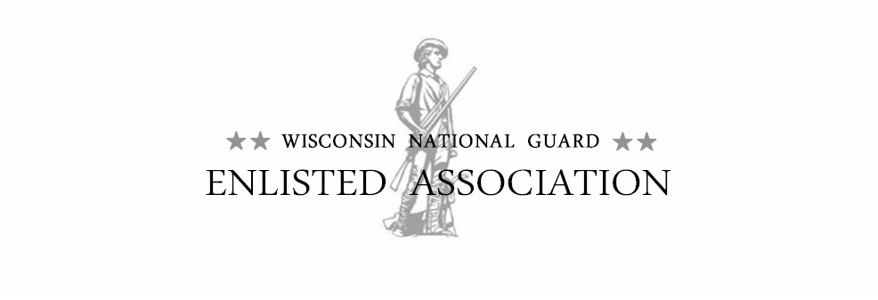
To All Executive Council Members 12 Jan 2025

This is to notify you that there will be a quarterly WNGEA Executive Council meeting.

Date: 25 April 2025 (Friday) Place date on your calendar!
Time: 1600-1700 hours
Place: Double Tree Madison East, Nekoosa Room
Report Period: January to March 2025
Committee Reports due by: COB: Monday/21 April 2025

The April Executive Council meeting will be held at the Double Tree by Hilton Madison East in Madison, WI. Water will be available during the meeting.

Conference Call option will be available as follows: Local: 608.242.3802 or 608-242.3805.
Toll free: 1.877.533.6691, entry code: 23114#

If you have a quarterly report for this meeting it should reflect the business and issues for 2025. If you are unable to attend the meeting, please notify me via email, phone call, or text (920-723-8098). If you have input for Old or New Business, please include your comments when you send your report.

On Tuesday (22 April), after the report due date, reports will be printed and assembled in the reports packet for the meeting. Upon receipt, I will send a confirmations that I received your report. If you do not receive a confirmation, contact me for clarification. For anyone that cannot or did not meet this deadline, please bring your reports to the meeting. New information, or a negative report can be presented orally to save paper, and it will be recorded into the minutes.

Please forward this notification to anyone you know who may be interested in knowing more about the association.

Sincerely:

//signed//
Gary R. Hans, Sergeant Major, Retired
WNGEA Executive Director
920-723-8098

