
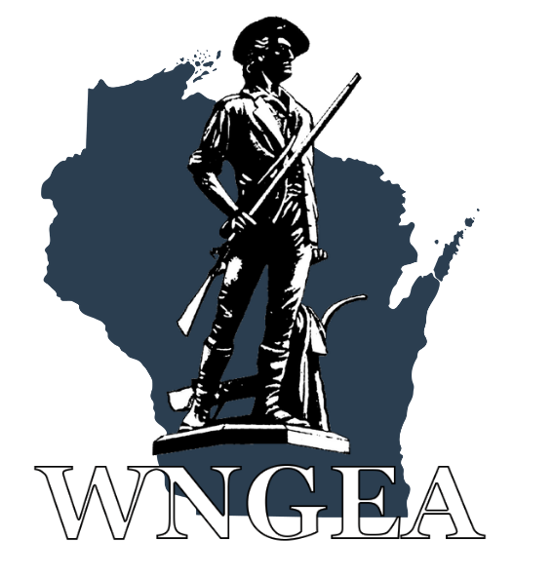

Wisconsin National Guard Conference
Child Care Memorandum

WINGA and WNGEA are happy to offer childcare for Friday and Saturday evening to allow those members with young children to attend with their spouse or guest. We hope this will add to the experience and all maximum participation during the event.
- Events Covered: Ice Breaker – Friday Night and the Banquet – Saturday Night.
(1800 to 2100)
- Singing up:
  - Members will be able to sign-up their children for childcare utilizing either the electronic (website) or manual registration functions.
  - Members will also have the option to sign-up at the conference, but space will be limited to the number of attendants we have (no more than a 10 to 1 ratio).
- Parent(s)’ Responsibilities:
  - Members, from now on referred to as parents, will leave point of contact information with the childcare room attendants – i.e. a cell phone number. Parents will be contacted if one of the following issues arise.
    - Parents will be responsible for all potty incidents where the child is not fully potty trained. Childcare providers will escort children to and from bathrooms, but will not assist with wiping, diaper changes, etc. Parents will be called/texted to the childcare room to further assist their child.
    - The child is misbehaving to the point that attendants can no longer keep him/her safe or other children safe. Incidents include biting, kicking, hitting, yelling/screaming (for a sustained period of time), etc.
  - Children will NOT be fed dinner at childcare. Parents MUST feed their children prior to drop-off. Snacks will be available, but nothing substantial and will be on a first come first serve basis.

Regards,

Your Conference Committee

